Guía2. Desarrollo Proyecto APT
Asignatura Capstone

1. Project Progress Summary – APT
Below, you will find different fields that must be completed with the requested information.

Project Progress Summary | In this phase, we have been working as a team on both the backend and the frontend. We have developed the database responsible for storing user information so that they can register in our application, log in afterward, and then navigate the app from the frontend. Currently, the system allows user registration, role assignment (athlete or coach), credential validation, access to the home screen, and navigation within the app. We are now working on session persistence to ensure that the session remains active after restarting the app, as well as on error handling, profile design, and profile editing functionalities that are still under development.
Objectives | We have successfully completed sprints 0 and 1, and we are currently working on sprint 2. Our goal is to complete it soon and move on to sprint 3 in order to reduce the workload and continue progressing through sprint 4 and beyond, thus giving better structure and functionality to our application.
Methodology | Our work methodology is based on the assigned sprints as a team, where we plan and execute activities with specific task durations. This approach has allowed us to steadily advance in the project’s development.
Evidence of Progress | Functional demonstrations of the following features already implemented:  - User registration: account creation in the database with credential validation.  - Role assignment: distinction between athlete and coach accounts at registration.  - Login: credential validation and successful access to the application.  - Home screen and basic navigation: access to the main interface and movement across app sections.  - Session persistence: initial prototype to keep the session active after restarting the app.  - Profile design: initial structure of the user profile view and personal data editing.  These pieces of evidence demonstrate the project’s progress, as they reflect partial fulfillment of the objectives defined in the initial sprints, resulting in a system that already integrates backend, frontend, and database functionalities.

2. Work Plan Monitoring
Carefully review your work plan, focusing especially on the column for progress status and adjustments.
Examina cuidadosamente tu plan de trabajo, enfocándose especialmente en la columna de estado de avance y ajustes.
Plan de Trabajo
Competencia o unidades de competencias | Actividades | Recursos | Duración de la actividad | Responsable | Observaciones | Estado de avance | Ajustes
Base de datos, Desarrollo de aplicaciones móviles, gestión de proyectos | Nombra las actividades que se necesitan para desarrollar el proyecto APT. | Nombra los recursos necesarios para llevar a cabo las actividades definidas. | Señala la duración de cada actividad. | Escribe el nombre del integrante del equipo responsable de cada actividad. | Señala las dificultades o facilitadores que se podrían presentar durante la ejecución de cada una de las actividades propuestas. | Describe el estado de avance de cada actividad.  Tipos de estado:  En curso/ Con retraso/ No iniciado/ Completado/ Ajustada | Señala los ajustes o reformulaciones que has realizado.

(FOR THE MONITORING OF OUR WORK PLAN, WE USE SPRINTS, WHICH ARE DOCUMENTED BELOW)

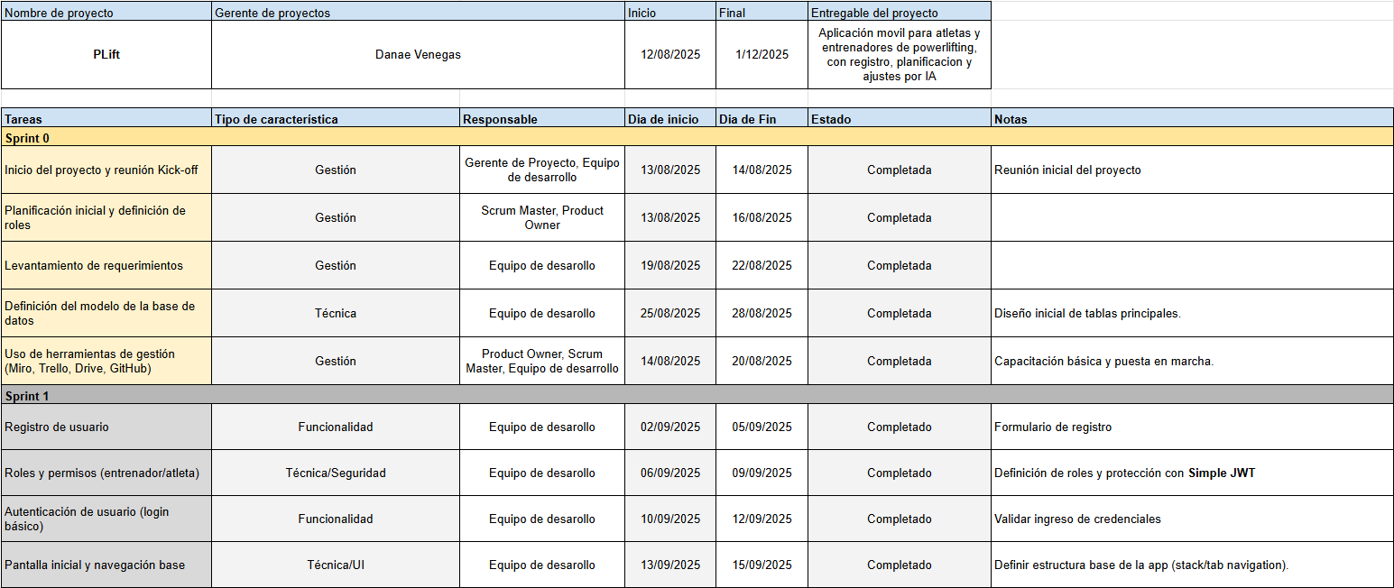
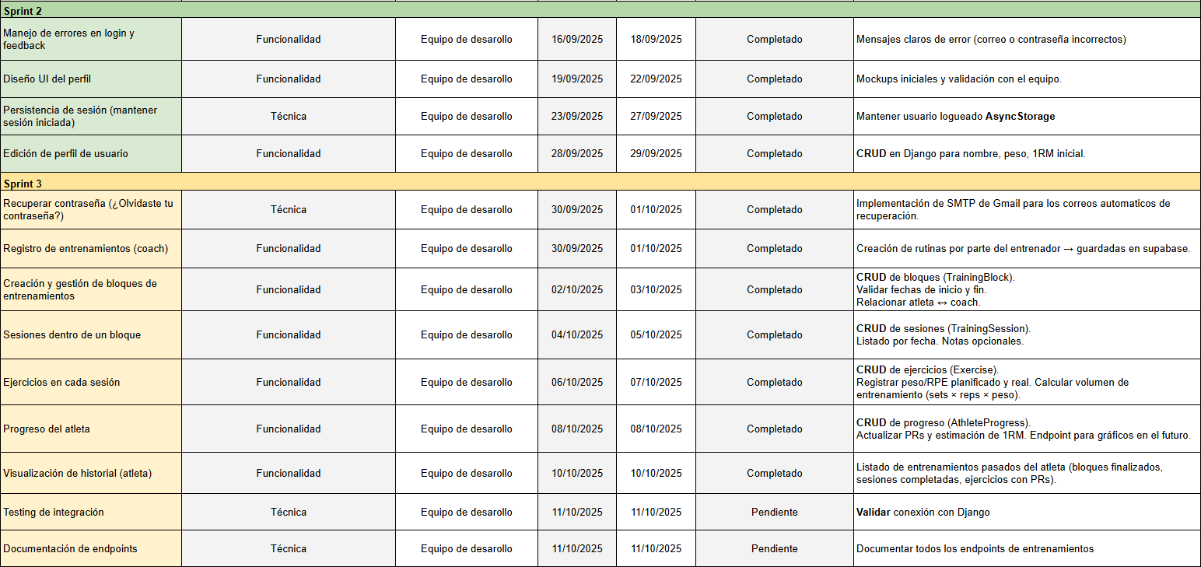
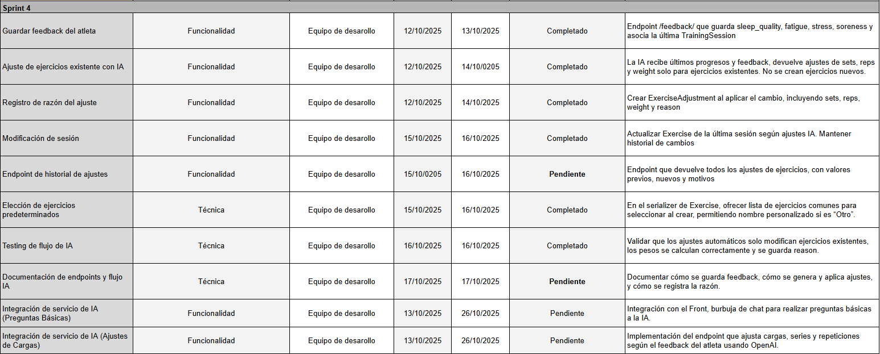
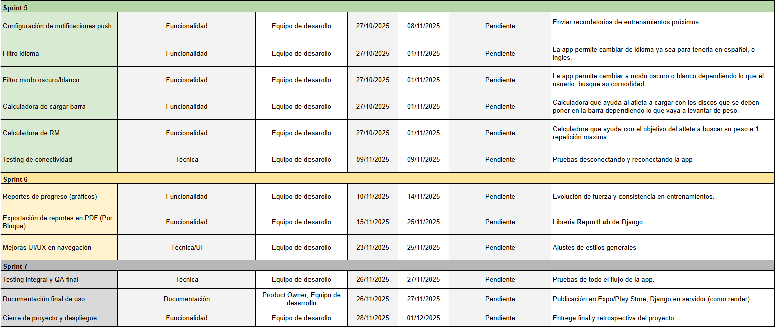

- In the latest version of our Sprint Planning, we decided to cut several tasks that we had initially considered, as the available time wasn’t sufficient to complete them. We chose to reduce the scope in order to focus on the application’s core functionalities and ensure it would be presentable and functional by the established deadline. Additionally, we incorporated a few low-complexity extra features that didn’t require much time to implement but delivered immediate value to the user experience.

3. Adjustments Based on Monitoring
Deepen the observations of your work plan. Analyze the planned activities and indicate which aspects facilitated or hindered the execution of the plan. Explain how you addressed and/or will address the obstacles. Finally, point out the adjustments you made to the work plan based on this analysis.

Factors that have Facilitated and/or Hindered the Development of My Work Plan:
One of the main factors that has facilitated the development of our APT Project is the adoption of the agile SCRUM methodology. This methodology has allowed us to better organize and prioritize tasks according to their importance, assigning clear responsibilities and deadlines for each activity. As a result, we have been able to maintain constant communication within the team and quickly adjust sprints when unexpected situations arise.
As for the difficulties, one of the main issues was that we progressed with other sprints instead of strictly following the planning established in Excel. This decision turned out not to be the best one, as it caused disorder in the sequence of activities. However, once we detected that we had advanced more tasks than originally planned, we decided to restructure the Sprint Planning. We now have a new, organized version that reflects both completed and pending activities in their proper order.

Adjusted or Removed Activities
We had to make adjustments to the activities because, at times, we worked on tasks corresponding to other sprints, which created some confusion regarding the planned order in Excel. To address this, we reviewed and updated our Sprint Planning to reorganize the tasks already completed and restructure the schedule. With this updated and more organized plan, we now have a clearer guide to continue project development in a more controlled and efficient manner.

Activities Not Started or Delayed
The activities that we have not yet started mainly correspond to the sprints scheduled for future stages. We have chosen to progress in an orderly manner, following the planned sprint sequence, to avoid confusion and ensure that each stage is completed correctly before starting the next.
To prevent delays and avoid affecting the APT project, we are reinforcing our schedule control and assigning clear responsibilities and deadlines for each task. In addition, we have established more frequent follow-up meetings to anticipate potential issues and reschedule or redistribute activities if necessary.

En caso de que el Proyecto APT sea grupal, en esta columna deben indicar el nombre de los responsables de cada tarea o actividad. Esto posteriormente permitirá diferenciar la evaluación por cada integrante.

